IBM CLOUD

**ASSIGNMENT – 3 bb**

1. 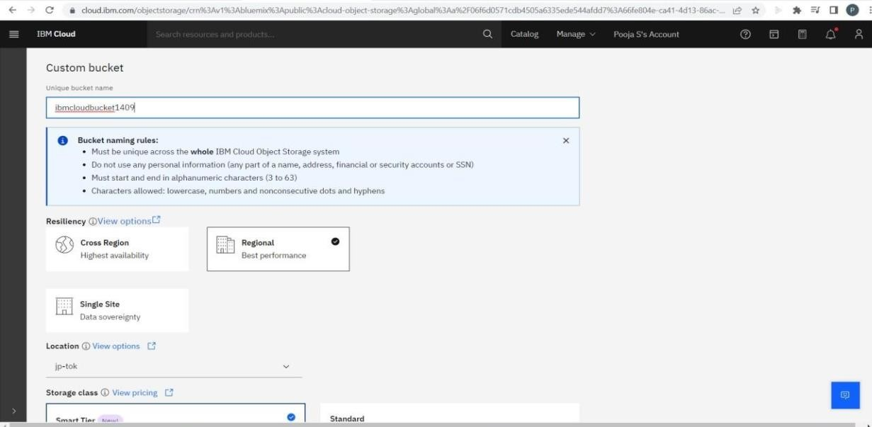Create a Bucket in IBM object storage.

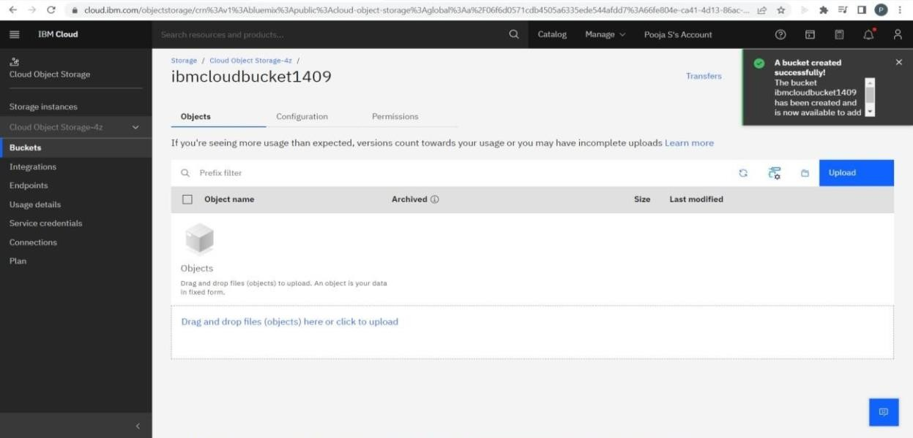

1. Upload an 5 images to ibm object storage and make it public. write html code to displaying all the 5 images.

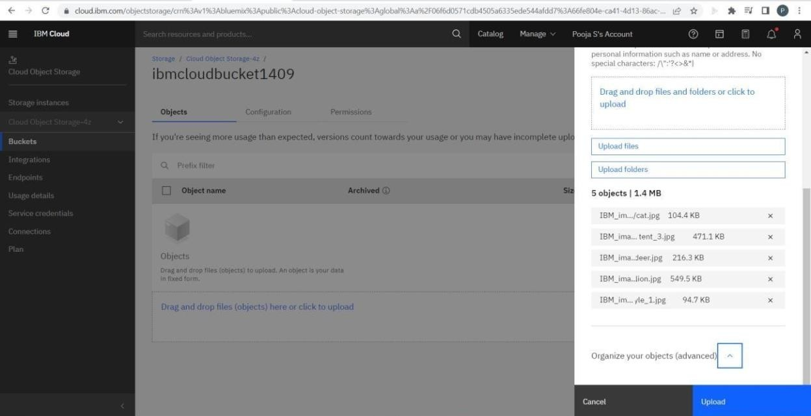Code File : display.html Uploading Images

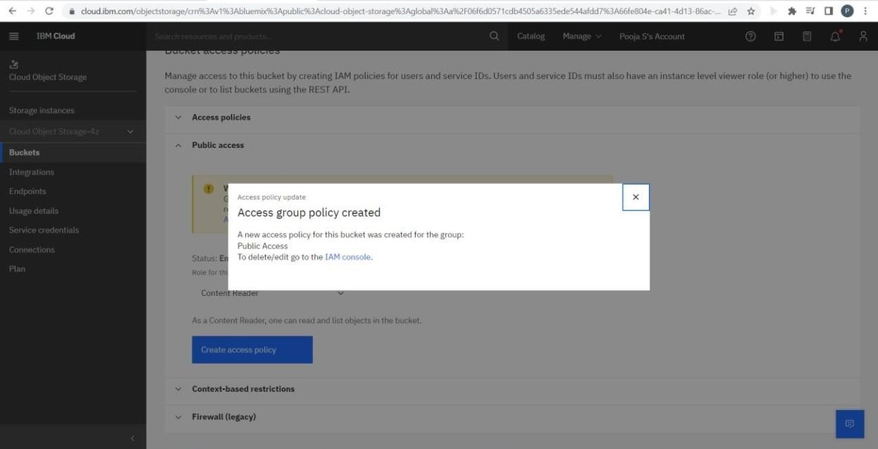

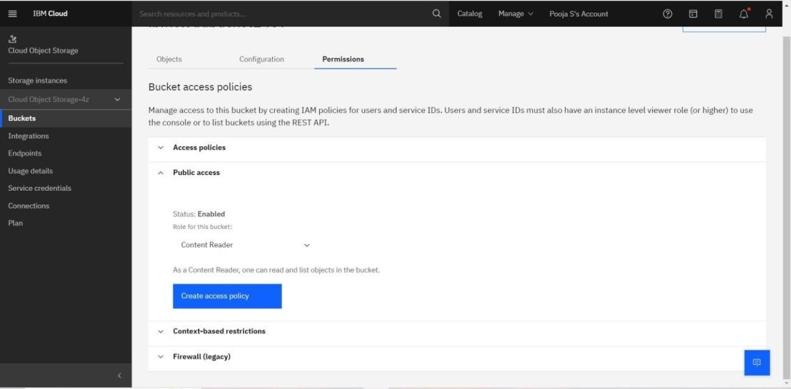

Style file present in local machine

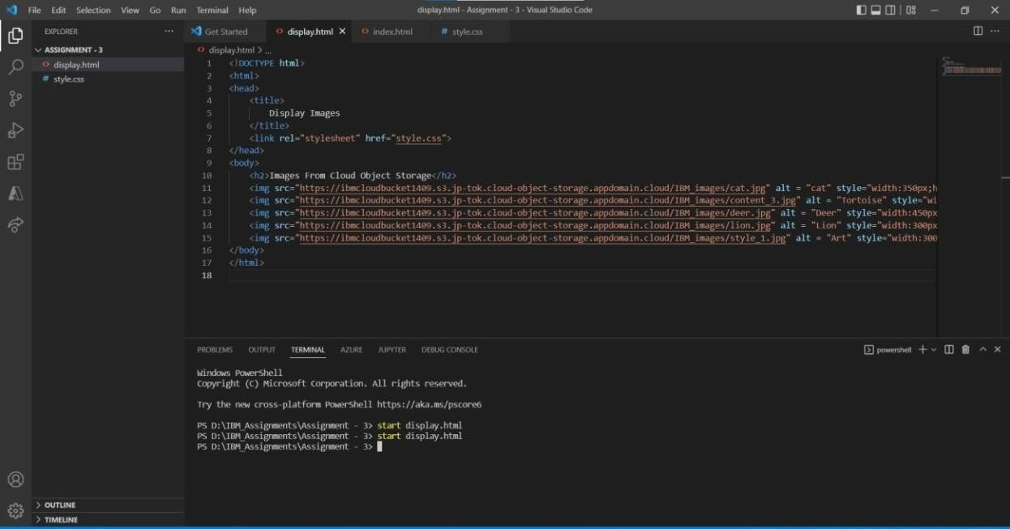

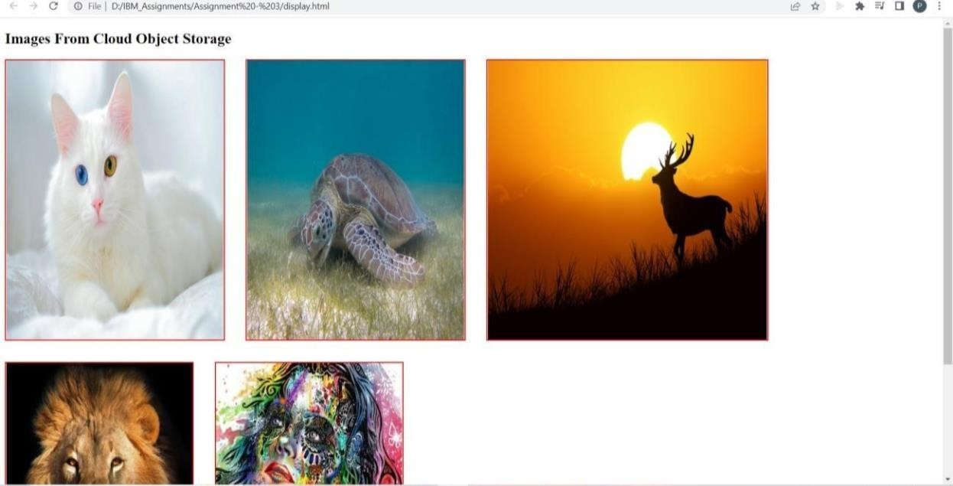

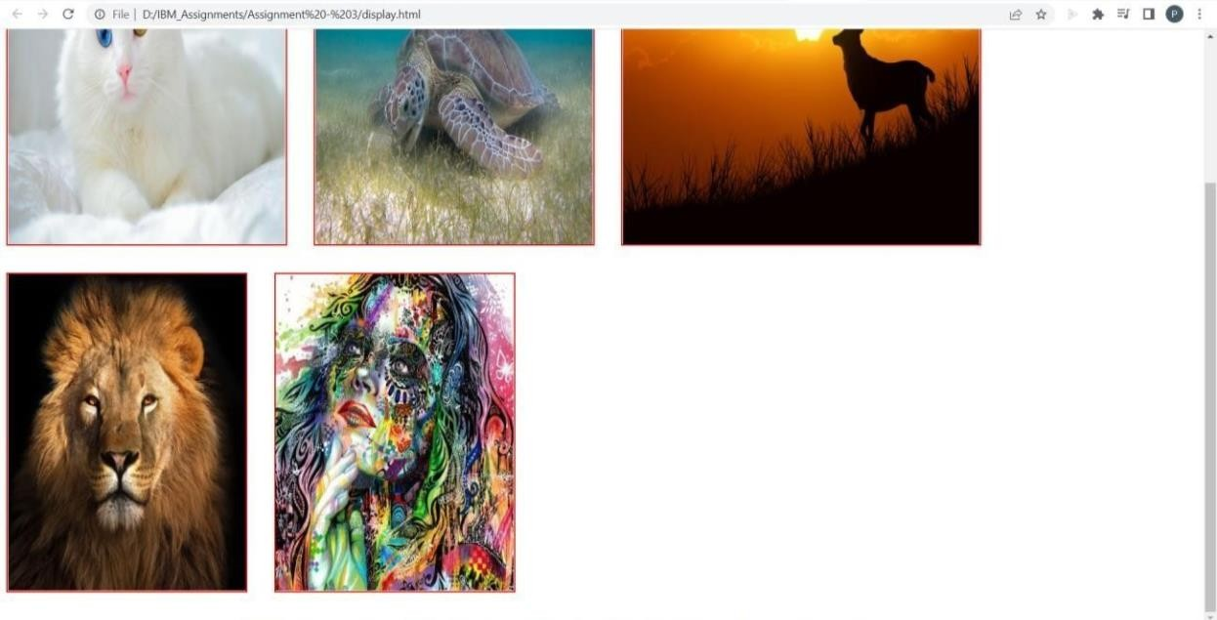

1. Upload a css page to the object storage and use the same page in your HTML code.

Code File : display_que3.html

Uploading Style page to cloud object storage

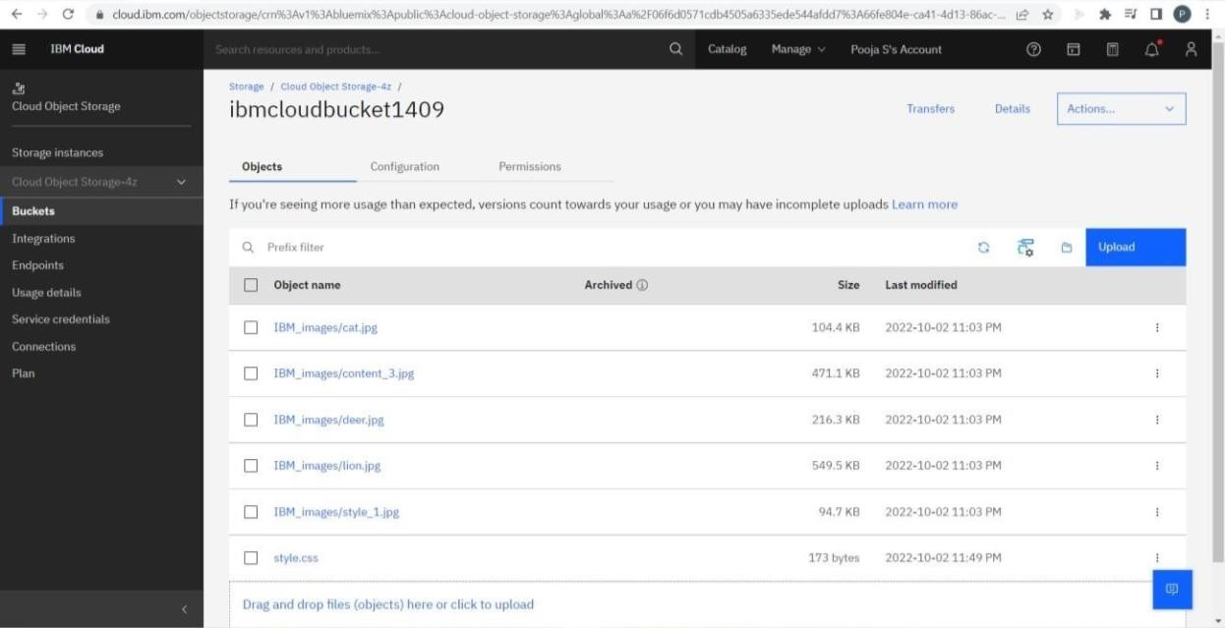

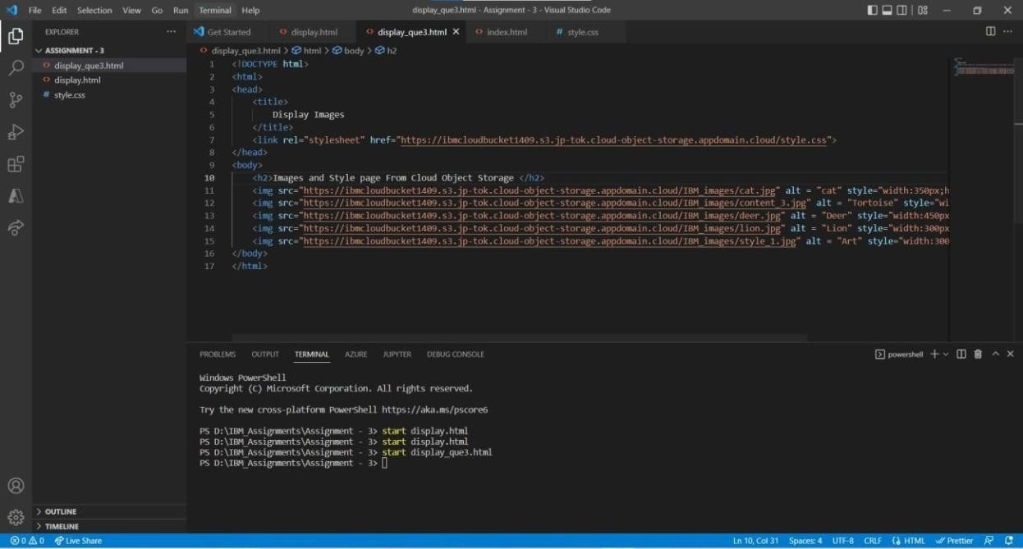Using the style page from cloud object storage

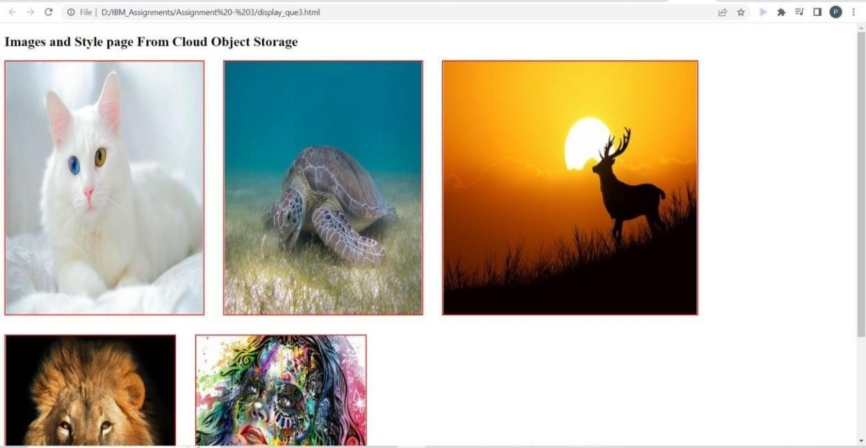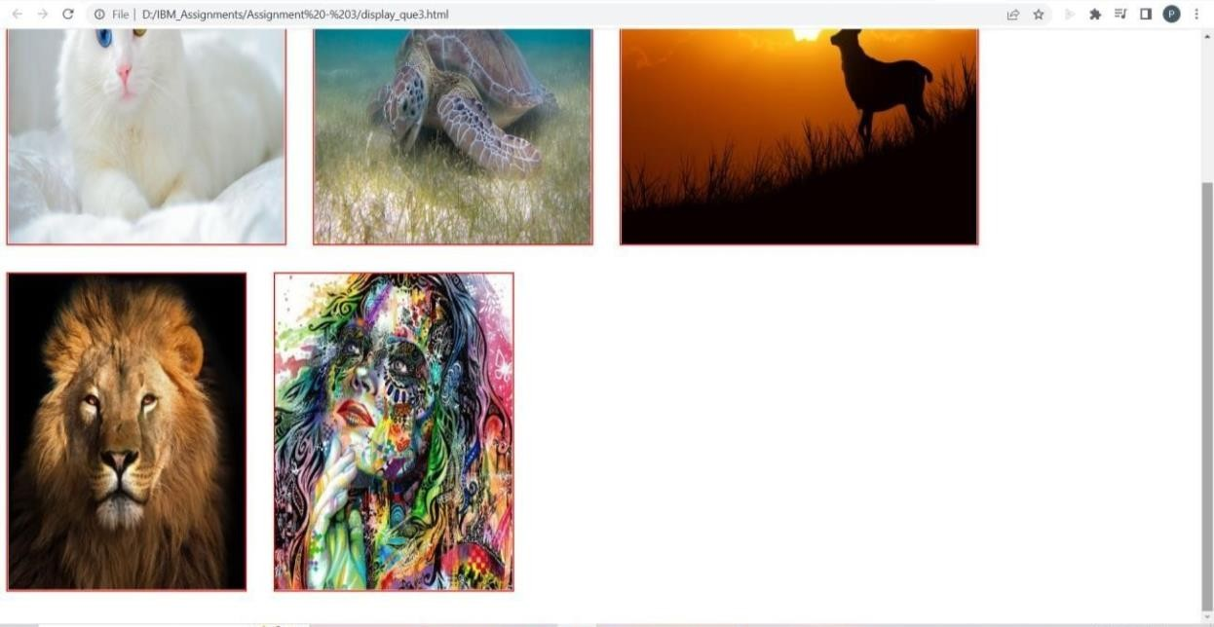

1. Design a chatbot using IBM Watson assistant for hospital. Ex: User comes with query to know the branches for that hospital in your city. Submit the web URL of that chat bot as a assignment.

[https://au-](https://au-syd.assistant.watson.cloud.ibm.com/crn%3Av1%3Abluemix%3Apublic%3Aconversation%3Aau-syd%3Aa%2F06f6d0571cdb4505a6335ede544afdd7%3A30b01793-f193-4ada-a147-4610ae753688%3A%3A/assistants/66fe2a12-a81a-4e69-9d76-ef76649699e3/preview) [syd.assistant.watson.cloud.ibm.com/crn%3Av1%3Abluemix%3Apublic%3Aconve](https://au-syd.assistant.watson.cloud.ibm.com/crn%3Av1%3Abluemix%3Apublic%3Aconversation%3Aau-syd%3Aa%2F06f6d0571cdb4505a6335ede544afdd7%3A30b01793-f193-4ada-a147-4610ae753688%3A%3A/assistants/66fe2a12-a81a-4e69-9d76-ef76649699e3/preview) [rsation%3Aau-](https://au-syd.assistant.watson.cloud.ibm.com/crn%3Av1%3Abluemix%3Apublic%3Aconversation%3Aau-syd%3Aa%2F06f6d0571cdb4505a6335ede544afdd7%3A30b01793-f193-4ada-a147-4610ae753688%3A%3A/assistants/66fe2a12-a81a-4e69-9d76-ef76649699e3/preview)

[syd%3Aa%2F06f6d0571cdb4505a6335ede544afdd7%3A30b01793-f193-4ada-](https://au-syd.assistant.watson.cloud.ibm.com/crn%3Av1%3Abluemix%3Apublic%3Aconversation%3Aau-syd%3Aa%2F06f6d0571cdb4505a6335ede544afdd7%3A30b01793-f193-4ada-a147-4610ae753688%3A%3A/assistants/66fe2a12-a81a-4e69-9d76-ef76649699e3/preview) [a147-4610ae753688%3A%3A/assistants/66fe2a12-a81a-4e69-9d76-](https://au-syd.assistant.watson.cloud.ibm.com/crn%3Av1%3Abluemix%3Apublic%3Aconversation%3Aau-syd%3Aa%2F06f6d0571cdb4505a6335ede544afdd7%3A30b01793-f193-4ada-a147-4610ae753688%3A%3A/assistants/66fe2a12-a81a-4e69-9d76-ef76649699e3/preview) [ef76649699e3/preview](https://au-syd.assistant.watson.cloud.ibm.com/crn%3Av1%3Abluemix%3Apublic%3Aconversation%3Aau-syd%3Aa%2F06f6d0571cdb4505a6335ede544afdd7%3A30b01793-f193-4ada-a147-4610ae753688%3A%3A/assistants/66fe2a12-a81a-4e69-9d76-ef76649699e3/preview)

1. Create Watson assistant service with 10 steps and use 3 conditions in it. Load that script in HTML page.

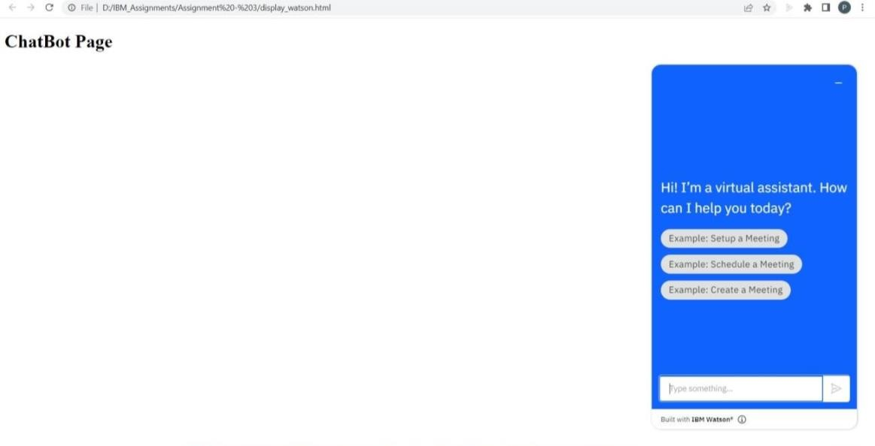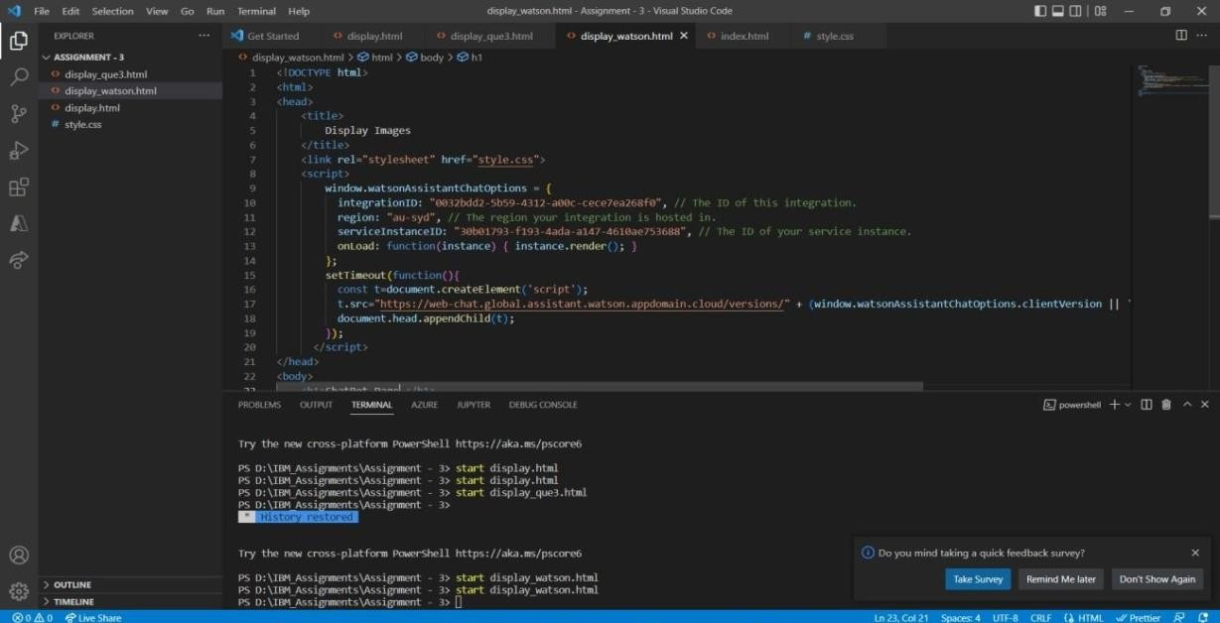Code File : display_watson.html